Techniques in Molecular Biology

- DNA Electrophoresis in Agarose Gel (Maniatis et al. 1982)

Electrophoresis of DNA or RNA in gels is a rapid and relatively inexpensive method by which DNA can be checked for size, intactness, homogeneity, and purity. This technique is core of molecular biology techniques. Separation of DNA can be achieved in polyacrylamide or most preferably in agarose gels.
Agarose forms a gel by hydrogen bonding and the gel pore size depends on the agarose concentration. Agarose, which is a polysaccharide from seaweed, is used routinely as the gel matrix for the electrophoretic separation of medium-size nucleic acid molecules. A 1.0% agarose gel can resolve duplex DNA chains that range from about 600 to 10,000 bp. Specialized Agarose Gel Electrophoresis (AGE) systems are available for fractionating DNA molecules with millions of base pairs, denatured DNA, and denatured RNA.
The DNA molecules are separated by electrophoresis on the basis of their size, shape, and the magnitude of net charge on the molecules. In general, a sample of one particular type of macromolecule (protein, DNA, or RNA) is placed in a well at or near the end of a gel matrix (gel).
The composition of an electrophoresis gel is a semisolid open meshwork of interlinked linear strands. A gel is cast as a thin slab with a number of sample wells. After the wells of a gel are loaded with sample, an electric field is applied across the gel, and charged macromolecules of the same size are driven together in the direction of the anode through the gel as discrete invisible bands of material.
The distance that a band moves into a gel depends on the mass of its macromolecules and the size of the openings (pore size) of the gel. The smaller macromolecules travel further than the larger ones. The progress of gel electrophoresis is monitored by observing the migration of a visible dye (tracking dye) through the gel. The tracking dye is a charged, low-molecular-weight compound that is loaded into each sample well at the start of a run. When the tracking dye reaches the end of the gel, the run is terminated.
DNA, RNA or Protein is separated into discrete bands on the basis of size. If there is little or no difference among the sizes of the macromolecules in a concentrated sample, a smear of stained material is observed. The bands, which are aligned in a lane under each well, are visualized by staining the gel with a dye that is specific for protein, DNA, or RNA. In case of DNA and RNA, Ethidium bromide (EtBr) dye is used which intercalates between the bases of RNA and DNA gives fluorescences orange when irradiated with UV light. Low concentration agarose gels with large pore permit fractionation of high MW molecules and vice versa. The size or molecular weight of macromolecule is determined by comparing with standard markers which is run in one or both of the outside lanes (calibrator lanes) of the same gel as the samples.
Specialized agarose gel electrophoresis systems are available for fractionating DNA molecules with millions of base pairs, denatured DNA, and denatured RNA. In addition, for specific purposes, polyacrylamide gels are used for separating DNA molecules.

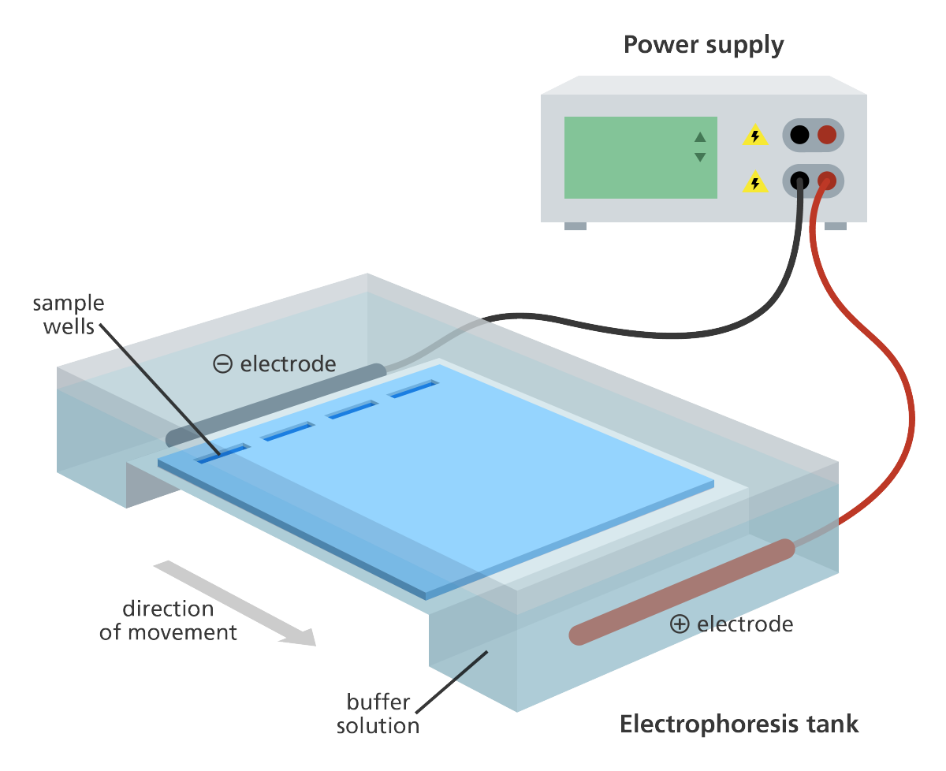
Horizontal Gel Electrophoresis

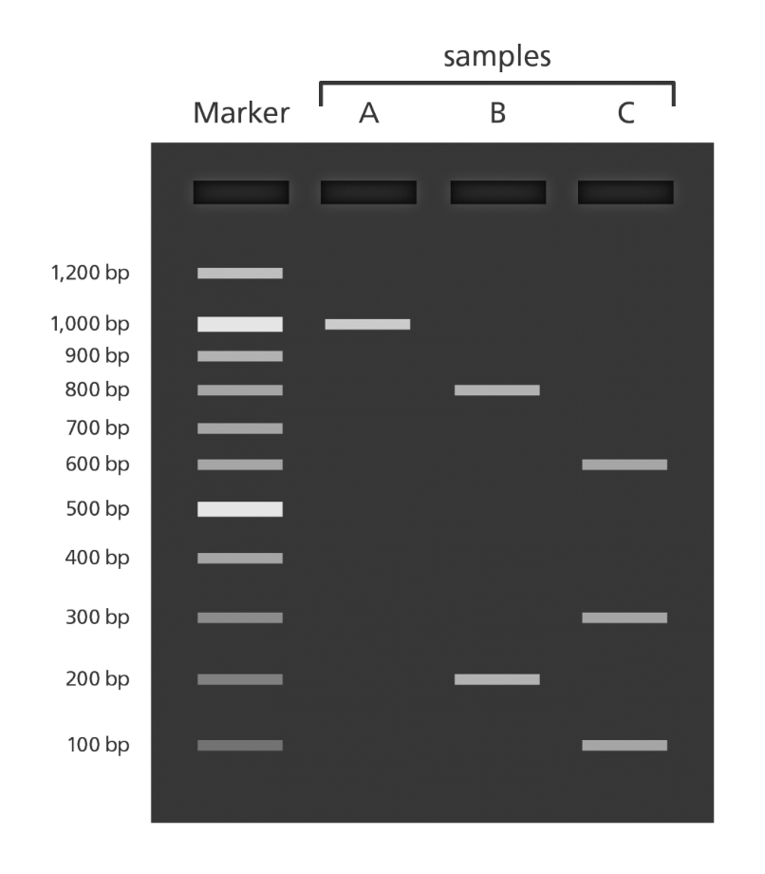
Illustration showing DNA bands separated on a gel. The length of the DNA fragments is compared to a marker containing fragments of known length.

Vertical Gel Electrophoresis
- PAGE- Poly acrylamide Gel Electrophoresis
Polyacrylamide is the preferred gel system for separating proteins. Electrophoretic procedures are rapid and relatively sensitive requiring only micro-weights of proteins Electrophoresis of proteins in polyacrylamide gels is carried out in buffer gels (non-denaturing) as well as in sodium dodecyl sulphate (SDS) containing (denaturing) gels.
Separation in buffer gels relies on both the charge and size of the protein, whereas it depends only upon the size in the SDS-gels. Analysis and comparison of proteins in a large number of samples is easily made on polyacrylamide gel slabs. Polyacrylamide gels are formed by polymerizing acrylamide with cross-linking agent (bisacrylamide) in the presence of a catalyst (persulphate ion) and chain initiator (TEMED; N,N,N,N-tetramethylethylene diamine).
The pore size of a polyacrylamide gel is determined by the concentration of acrylamide and the ratio of acrylamide to bisacrylamide. For many applications, a protein sample is treated with the anionic detergent sodium dodecyl sulfate (SDS) before electrophoresis. The SDS binds to proteins and dissociates most multi chain proteins. Each SDS-coated protein chain has a similar charge-to-mass ratio. Consequently, during electrophoresis, the separation of the SDS– protein chains is based primarily on size, and the effect of conformation is eliminated.
Polyacrylamide gel electrophoresis (PAGE) is a technique widely used in biochemistry, forensic chemistry, genetics, molecular biology and biotechnology to separate biological macromolecules, usually proteins or nucleic acids, according to their electrophoretic mobility.
Following electrophoresis, the gel may be stained (for proteins, most commonly with Coomassie Brilliant Blue or autoradiography; for nucleic acids, ethidium bromide; or for either, silver stain), allowing visualization of the separated proteins, or processed further (e.g. Western blot).
After staining, different species biomolecules appear as distinct bands within the gel.

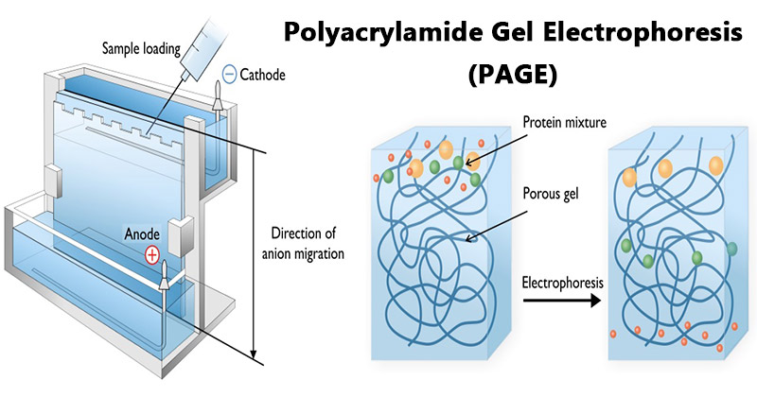

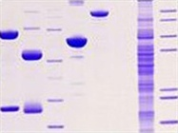
Protein Gel stained with Coomassie Brilliant Blue

References
- Rajan Katoch , Analytical Techniques in Biochemistry and Molecular Biology. Springer
- Peter Russell, iGenetics, A Molecular Approach, Pearson Benjamin Cummings, New York.
- T.A. BROWN, Gene Cloning and DNA Analysis, Wiley Blackwell Publications.

